Practical 11
Q) To implement Principal Component Analysis (PCA) for dimensionality reduction, visualize the
reduced data and evaluate its effectiveness using a classification algorithm.
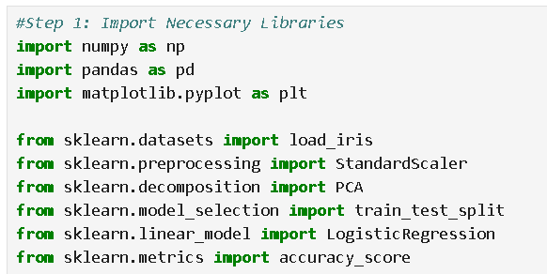
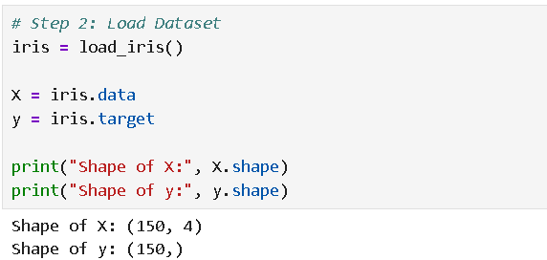
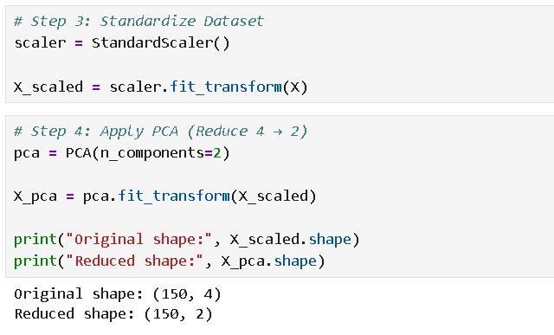
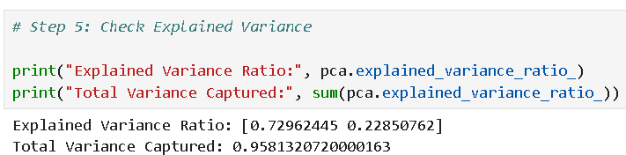
Variance = how much data is spread out.
If values are very different → high variance
If values are similar → low variance

Marks of students:
Class A:
50, 51, 50, 49, 50
→ very small spread → low variance
Class B:
10, 95, 40, 80, 60
→ big spread → high variance
High variance = more information
Low variance = less information
PCA keeps directions where variance is maximum.
That is why:
PC1 captures maximum variance
PC2 captures second highest variance

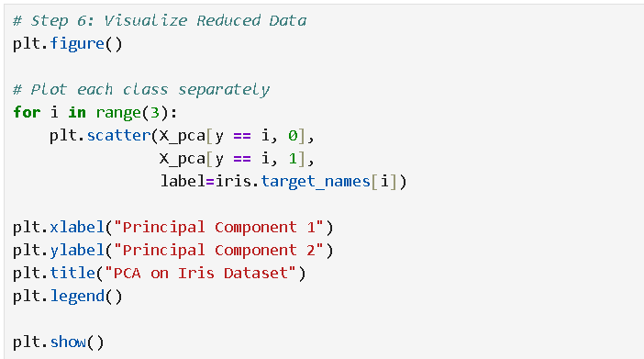
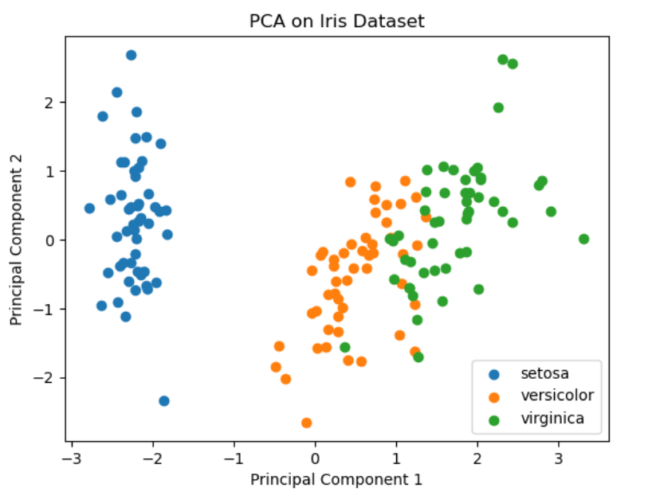
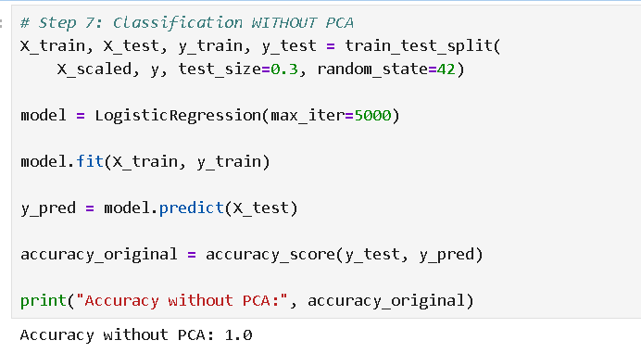
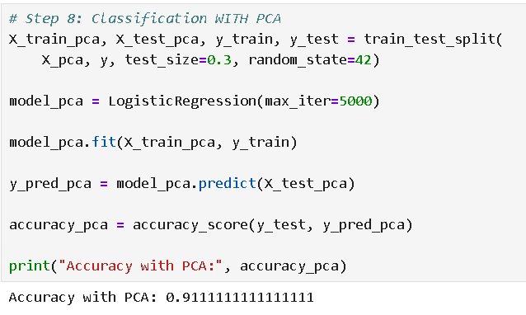

It contains measurements of iris flowers belonging to 3 species.
Features in Iris Dataset
Each flower has 4 measurements:
- Sepal Length (cm)
- Sepal Width (cm)
- Petal Length (cm)
- Petal Width (cm)
Target (Output Variable)
3 flower species:
- Setosa
- Versicolor
- Virginica
So it is a multiclass classification problem.
Dataset Size
- 150 rows (flowers)
- 4 features
- 1 target column

